

Packet Tracer - Configure Extended ACLs - Scenario 1

Nombre: Luis Enrique Pérez Señalin

# Addressing Table

|  |  |  |  |  |
| --- | --- | --- | --- | --- |
| **Device** | **Interface** | **IP Address** | **Subnet Mask** | **Default Gateway** |
| R1 | G0/0 | 172.22.34.65 | 255.255.255.224 | N/A |
| G0/1 | 172.22.34.97 | 255.255.255.240 |
| G0/2 | 172.22.34.1 | 255.255.255.192 |
| Server | NIC | 172.22.34.62 | 255.255.255.192 | 172.22.34.1 |
| PC1 | NIC | 172.22.34.66 | 255.255.255.224 | 172.22.34.65 |
| PC2 | NIC | 172.22.34.98 | 255.255.255.240 | 172.22.34.97 |

**Objectives**

**Part 1: Configure, Apply and Verify an Extended Numbered ACL Part 2: Configure, Apply and Verify an Extended Named ACL**

# Background / Scenario

Two employees need access to services provided by the server. **PC1** only needs FTP access while **PC2** only needs web access. Both computers need to be able to ping the server, but not each other.

# Instructions

**Part 1: Configure, Apply and Verify an Extended Numbered ACL**

## Step 1: Configure an ACL to permit FTP and ICMP from PC1 LAN.

1. From global configuration mode on **R1**, enter the following command to determine the first valid number for an extended access list.

R1(config)# **access-list ?**

<1-99> IP standard access list

<100-199> IP extended access list

1. Add **100** to the command, followed by a question mark.

R1(config)# **access-list 100 ?** deny Specify packets to reject permit Specify packets to forward remark Access list entry comment

1. To permit FTP traffic, enter **permit,** followed by a question mark.

R1(config)# **access-list 100 permit ?** ahp Authentication Header Protocol eigrp Cisco's EIGRP routing protocol esp Encapsulation Security Payload

gre Cisco's GRE tunneling

icmp Internet Control Message Protocol ip Any Internet Protocol

ospf OSPF routing protocol

tcp Transmission Control Protocol udp User Datagram Protocol

1. When configured and applied, this ACL should permit FTP and ICMP. ICMP is listed above, but FTP is not. This is because FTP is an application layer protocol that uses TCP at the transport layer. Enter TCP to further refine the ACL help.

R1(config)# **access-list 100 permit tcp ?**

A.B.C.D Source address any Any source host

host A single source host

1. The source address can represent a single device, such as PC1, by using the **host** keyword and then the IP address of PC1. Using the keyword **any** permits any host on any network. Filtering can also be done by a network address. In this case, it is any host that has an address belonging to the 172.22.34.64/27 network. Enter this network address, followed by a question mark.

R1(config)# **access-list 100 permit tcp 172.22.34.64 ?**

A.B.C.D Source wildcard bits

1. Calculate the wildcard mask by determining the binary opposite of the /27 subnet mask.

**11111111.11111111.11111111.111**00000 = 255.255.255.224

00000000.00000000.00000000.000**11111** = 0.0.0.31

1. Enter the wildcard mask, followed by a question mark.

### R1(config)# access-list 100 permit tcp 172.22.34.64 0.0.0.31 ?

A.B.C.D Destination address any Any destination host

eq Match only packets on a given port number

gt Match only packets with a greater port number host A single destination host

lt Match only packets with a lower port number neq Match only packets not on a given port number

range Match only packets in the range of port numbers

1. Configure the destination address. In this scenario, we are filtering traffic for a single destination, which is the server. Enter the host keyword followed by the server’s IP address.

### R1(config)# access-list 100 permit tcp 172.22.34.64 0.0.0.31 host

**172.22.34.62 ?**

dscp Match packets with given dscp value

eq Match only packets on a given port number established established

gt Match only packets with a greater port number lt Match only packets with a lower port number neq Match only packets not on a given port number precedence Match packets with given precedence value

range Match only packets in the range of port numbers

<cr>

1. Notice that one of the options is **<cr>** (carriage return). In other words, you can press **Enter** and the statement would permit all TCP traffic. However, we are only permitting FTP traffic; therefore, enter the **eq** keyword, followed by a question mark to display the available options. Then, enter **ftp** and press **Enter**.

### R1(config)# access-list 100 permit tcp 172.22.34.64 0.0.0.31 host

**172.22.34.62 eq ?**

<0-65535> Port number

ftp File Transfer Protocol (21) pop3 Post Office Protocol v3 (110)

smtp Simple Mail Transport Protocol (25) telnet Telnet (23)

www World Wide Web (HTTP, 80)

### R1(config)# access-list 100 permit tcp 172.22.34.64 0.0.0.31 host

**172.22.34.62 eq ftp**

1. Create a second access list statement to permit ICMP (ping, etc.) traffic from PC1 to Server. Note that the access list number remains the same and a specific type of ICMP traffic does not need to be specified.

### R1(config)# access-list 100 permit icmp 172.22.34.64 0.0.0.31 host

**172.22.34.62**

1. All other traffic is denied, by default.
2. Execute the **show access-list** command and verify that access list 100 contains the correct statements. Notice that the statement **deny any any** does not appear at the end of the access list. The default execution of an access list is that if a packet does not match a statement in the access list, it is not permitted through the interface.

### R1#show access-lists

Extended IP access list 100

10 permit tcp 172.22.34.64 0.0.0.31 host 172.22.34.62 eq ftp

20 permit icmp 172.22.34.64 0.0.0.31 host 172.22.34.62

## Step 2: Apply the ACL on the correct interface to filter traffic.

From **R1**’s perspective, the traffic that ACL 100 applies to is inbound from the network connected to the Gigabit Ethernet 0/0 interface. Enter interface configuration mode and apply the ACL.

**Note**: On an actual operational network, it is not a good practice to apply an untested access list to an active interface.

R1(config)# **interface gigabitEthernet 0/0**

R1(config-if)# **ip access-group 100 in**

## Step 3: Verify the ACL implementation.

1. Ping from PC1 to Server. If the pings are unsuccessful, verify the IP addresses before continuing.
2. FTP from PC1 to Server. The username and password are both **cisco**.

### PC> ftp 172.22.34.62

1. Exit the FTP service.

ftp> **quit**

1. Ping from PC1 to PC2. The destination host should be unreachable, because the ACL did not explicitly permit the traffic.

**Verification**

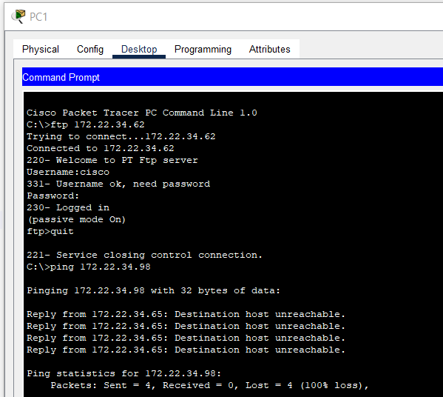

# Part 2: Configure, Apply and Verify an Extended Named ACL

## Step 1: Configure an ACL to permit HTTP access and ICMP from PC2 LAN.

1. Named ACLs start with the **ip** keyword. From global configuration mode of **R1**, enter the following command, followed by a question mark.

R1(config)# **ip access-list ?** extended Extended Access List standard Standard Access List

1. You can configure named standard and extended ACLs. This access list filters both source and destination IP addresses; therefore, it must be extended. Enter **HTTP_ONLY** as the name. (For Packet Tracer scoring, the name is case-sensitive and the access list statements must be the correct order.)

R1(config)# **ip access-list extended HTTP_ONLY**

1. The prompt changes. You are now in extended named ACL configuration mode. All devices on the **PC2**

LAN need TCP access. Enter the network address, followed by a question mark.

R1(config-ext-nacl)# **permit tcp 172.22.34.96 ?**

A.B.C.D Source wildcard bits

1. An alternative way to calculate a wildcard is to subtract the subnet mask from 255.255.255.255.

255.255.255.255

- 255.255.255.240

= 0. 0. 0. 15

R1(config-ext-nacl)# **permit tcp 172.22.34.96 0.0.0.15**

1. Finish the statement by specifying the server address as you did in Part 1 and filtering **www** traffic.

R1(config-ext-nacl)# **permit tcp 172.22.34.96 0.0.0.15 host 172.22.34.62 eq www**

1. Create a second access list statement to permit ICMP (ping, etc.) traffic from **PC2** to **Server**. Note: The prompt remains the same and a specific type of ICMP traffic does not need to be specified.

R1(config-ext-nacl)# **permit icmp 172.22.34.96 0.0.0.15 host 172.22.34.62**

1. All other traffic is denied, by default. Exit extended named ACL configuration mode.
2. Execute the **show access-list** command and verify that access list **HTTP_ONLY** contains the correct statements.

### R1# show access-lists

Extended IP access list 100

10 permit tcp 172.22.34.64 0.0.0.31 host 172.22.34.62 eq ftp

20 permit icmp 172.22.34.64 0.0.0.31 host 172.22.34.62

Extended IP access list HTTP_ONLY

10 permit tcp 172.22.34.96 0.0.0.15 host 172.22.34.62 eq www

20 permit icmp 172.22.34.96 0.0.0.15 host 172.22.34.62

## Step 2: Apply the ACL on the correct interface to filter traffic.

From **R1**’s perspective, the traffic that access list **HTTP_ONLY** applies to is inbound from the network connected to the Gigabit Ethernet 0/1 interface. Enter interface configuration mode and apply the ACL.

**Note**: On an actual operational network, it is not a good practice to apply an untested access list to an active interface. It should be avoided if possible.

R1(config)# **interface gigabitEthernet 0/1**

R1(config-if)# **ip access-group HTTP_ONLY in**

## Step 3: Verify the ACL implementation.

1. Ping from **PC2** to **Server**. If the ping is unsuccessful, verify the IP addresses before continuing.
2. From PC2 open a web browser and enter the IP address of the Server. The web page of the Server should be displayed.
3. FTP from **PC2** to **Server**. The connection should fail. If not, troubleshoot the access list statements and the access-group configurations on the interfaces.

**Verification**

**Captura de pantalla**

